1. **Agenda**:
   1. To show heartbeat mechanism.
2. 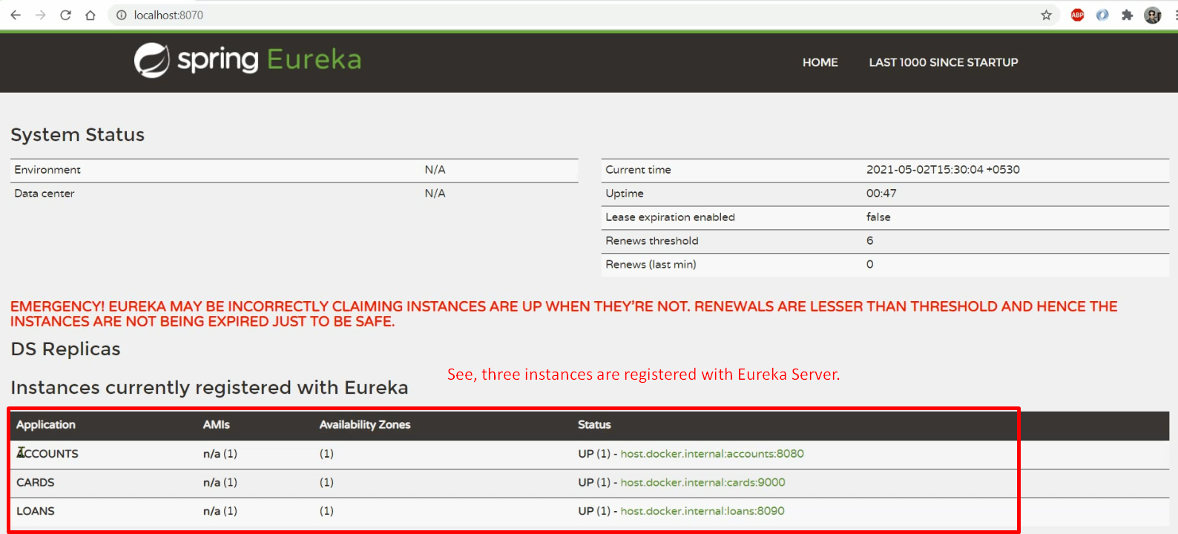
3. Let’s bring down the Eureka Server.
4. 
5. 